**1.PROGRAM CODE**

import java.util.stream.Collectors;  
import java.util.stream.Stream;  
import java.util.List;  
  
public class First {  
 public static void main(String[] args) {  
  
 // This creates a stream containing the elements "aBc", "d", and "ef".  
 Stream<String> names = Stream.of("aBc", "d", "ef");  
  
 List<String> upper = names.map(e -> e.toUpperCase()) // Convert each string to uppercase.  
 .collect(Collectors.toList()); // Collect the results into a List.  
  
 // Print the List of uppercase strings to the console.  
 System.out.println(upper);  
 }  
}

**OUTPUT**

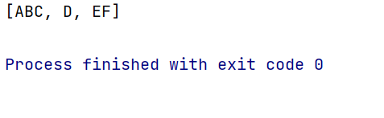

**2.PROGRAM CODE**

import java.util.Arrays;  
import java.util.List;  
import java.util.stream.Collectors;  
  
public class Second {  
 public static void main(String[] args) {  
  
 // Create a list of strings with some empty strings in it  
 List<String> list = Arrays.asList("abc", "", "bc", "efg", "abcd", "", "jkl");  
  
 List<String> l = list.stream()  
 .filter(e -> !(e.isEmpty())) // Keep strings that are not empty  
 .collect(Collectors.toList()); // Collect the filtered strings into a new list  
  
 // Print the filtered list  
 System.out.println(l);  
 }  
}

**OUTPUT**

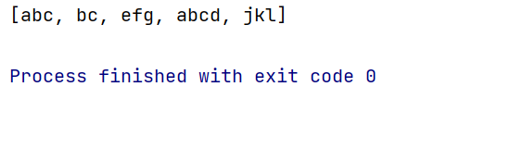

**3.PROGRAM CODE**  
import java.util.Arrays;  
import java.util.List;  
import java.util.stream.Collectors;  
  
public class Third {  
 public static void main(String[] args) {  
  
 // Initialize a list of student names  
 List<String> student = Arrays.asList("Hari", "Anbu", "Akash", "Monisha", "Shalini", "Vasu", "Kumar", "Priya", "Faheem", "Srinivasan");  
  
 List<String> gift = student.stream()  
 .filter(e -> e.startsWith("A")) // Keep names that start with 'A'  
 .collect(Collectors.toList()); // Collect the filtered names into a new list  
  
  
 System.out.println("Gift receiving students - " + gift);  
 }  
}

**OUTPUT**

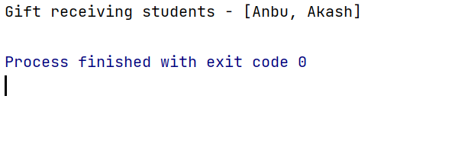

**4.PROGRAM CODE**  
import java.time.LocalDate;  
import java.time.Period;  
import java.util.Scanner;  
  
public class Four {  
  
 public static void main(String[] args) {  
  
  
 Scanner obj = new Scanner(System.in);  
  
 System.out.println("Enter your birthdate(yyyy-mm-dd): ");  
  
 // Read the user's input as a string  
 String dob = obj.nextLine();  
  
 // Parse the string into a LocalDate object using the format "yyyy-mm-dd"  
 LocalDate date = LocalDate.parse(dob);  
  
 // Get the current date as a LocalDate object  
 LocalDate currentdate = LocalDate.now();  
  
 // Calculate the period (difference) between the user's birthdate and the current date  
 Period age = Period.between(date, currentdate);  
  
  
 System.out.println("Your age is: " + age.getYears() + " years " + age.getMonths() + " months " + age.getDays() + " days");  
  
 obj.close();  
 }  
}

**OUTPUT**

